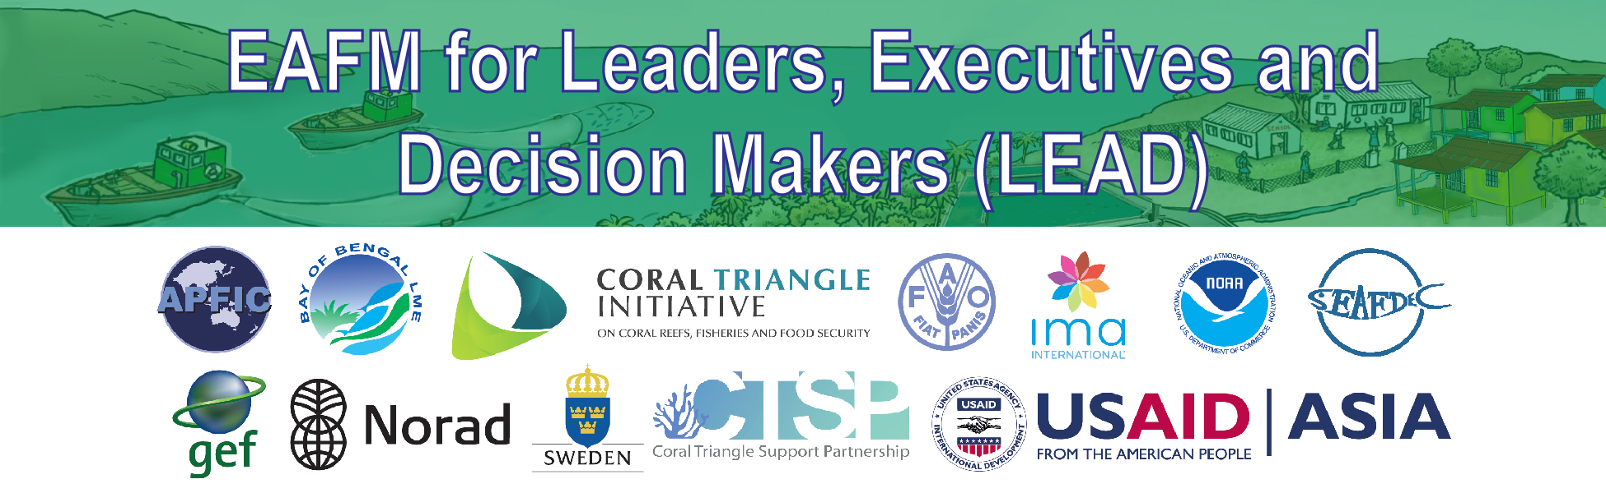
B5: Reference material

Policy trade-offs – when well-intentioned policies lead to conflicting outcomes

PURPOSE
To provide an opportunity for the participants on the LEAD Executive one-day course to review the major national policies and see how well they are integrated so that they support each other, and do not lead to conflicts or unintended negative outcomes.

HOW TO USE THIS DOCUMENT
This is a second activity to be included during the activity on the one-day executive course on “how many EAFM -type activities are you doing, and how well are they linked”.

- Once the LEAD course participants have identified the EAFM-type activities, they will then go on to identify the linkages.
- They should also be given time to identify/describe the key national policies in fisheries and aquaculture, and also any national policy that has strong direct or indirect impact on the fishery sector.
- The examples of how policies may contradict, or conflict should be presented (see below).
- After the example is presented, the LEAD course participants then discuss how well their policies support each other, and where there may be contradictions.

EXAMPLES OF POLICY CONTRADICTIONS

Well-intentioned policies and interventions that intended to support fisheries or development, may sometimes have conflicting outcomes…

Promoting fisheries development and fish exports.
Export income from fisheries and aquaculture is seen as a way of increasing wealth, employment and contributes to national development. Accessing higher value export markets is generally considered as desirable

But.
Promoting production (through subsidies, technical development, development of fish processing and fleet capacity and effort increases, lack of limits/controls) may have negative consequences on resources, leads to overfishing and resource decline. This may directly affect the segment you are trying to promote, or may affect other segments of the fishery (e.g. small-scale sector)

Aquaculture development to promote the economy, rural development and provide alternative employment
Aquaculture development is often seen as a way of moving fishing capacity out of fishing, a way if increasing coastal employment and development, and also taps into export income markets (e.g. shrimp aquaculture)

But…
The demands for fish and shrimp feeds often drives demands for low value fish to convert to fish meal. This can drive fishing effort, and direct targeting of small fish and contributes further to resource declines and overfishing. This can impact the resource and again, can have the biggest impact in the coastal fishery.

Short term subsidies often become long term dependencies
Buffering the fluctuations in market price for fish and operational costs such as fuel price, or policies that assist fisheries to reduce operational costs (such as allowing cheap unregulated foreign labour) can lead to undesirable consequences.

Short term subsidies often become long term dependencies and the sector cannot get free of the need for the subsidy. It often distorts the real economic value of fishing and so leads to excess fishing capacity and fishing effort (enabled by cheap fuel), beyond the level that the fishery can really support. Resources decline, and profitability per vessel also declines.

Trying to reduce operational costs by use of migrant labour
The use of cheap foreign labour can depress the national labour market and lead to local conflicts; it also opens the opportunity for unscrupulous employers, rights and labor abuses and even human trafficking.

Support in small-scale fisheries without placing control or allocation of user rights to control or limit expansion
Policies put in place to support small-scale fisheries can also have negative outcomes. By not placing limits on the expansion and technological development of small scale fisheries, or by providing hidden subsidies, the small scale coastal fishery can develop and expand too far.

This can reach a point that resources degrade and fisher’s incomes deteriorate. There are few alternatives for the fishers and this becomes a situations where is difficult reduce capacity and effort and leads to further subsidies.

Inviting foreign vessels or encouraging capacity movements to develop your own fisheries

Allowing the entry of foreign vessels or reflagging of foreign vessel is a common policy. It encourages in vessels to exploit resources which national fleet is not accessing. It is often part of an economic development plan or technical transfer policy (to “learn” from the foreign fleet and ultimately transfer to a domestic fleet)

This may lead to uncontrolled fishing, transshipping and “cheating or IUU by the foreign vessels. MCS is often inadequate to control their activity and instead of contributing to national economic development, the benefits end up in another country.
Examples of policy trade-offs. Policies shown with a tick can all result in declining fishery resources, increased conflicts between sub-sectors and less fish for the small-scale susector, which in turn contradict the policies shown with a cross.

